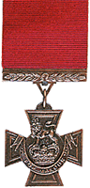 | Victoria Cross  Awarded for reaching the rank of Field Marshall.  United Kingdom Decoration...it's highest military honor.
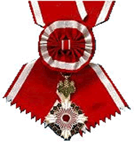 | Order of the Rising Sun  Awarded for reaching the rank of General.  Japansese Decoration...it's highest military honor.
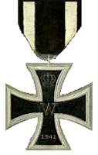 | Iron Cross  Awarded for reaching the rank of Lieutenant General.  German Decoration
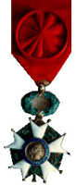 | Légion-d'Honneur  Awarded for reaching the rank of Major General.  French Decoration
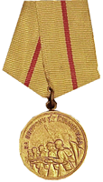 | Defense of Stalingrad  Awarded for reaching the rank of Brigadier General.  Russian Decoration
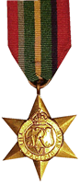 | Pacific Star  Awarded for reaching the rank of Colonel.  United Kingdom Decoration
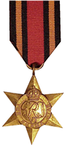 | Burma Star  Awarded for reaching the rank of Major.  United Kingdom Decoration
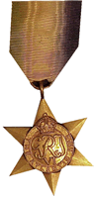 | Atlantic Star  Awarded for reaching the rank of Captain.  United Kingdom Decoration
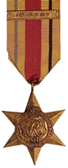 | African Star  Awarded for reaching the rank of 2nd Lieutenant.  United Kingdom Decoration
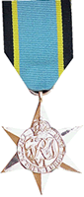 | Air Crew Star  Awarded for reaching the rank of Warrant Officer Class 1  United Kingdom Decoration
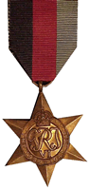 | 1939-1945 Service Star  Awarded for reaching the rank of Sergeant.  United Kingdom Decoration
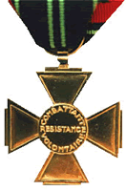 | French Resistance Volunteer  Awarded to all members of Balance of Power  (in good standing).  French Decoration
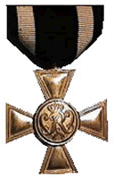 | Military Merit Cross  Awarded to all Balance of Power Cabinet members.  German Decoration
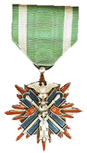 | Order of the Golden Kite  Awarded to members who have demonstrated outstanding volunteer service to Balance of Power either by action and/or monetary support.  This award is bestowed by the Commander in Chief and can be recomended by any Cabinet member.  Japansese Decoration
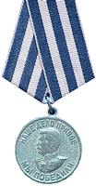 | Victory in Germany  Awarded for reaching a total games played of 100+  Russian Decoration
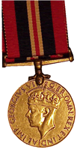 | WWII Service Medal  Awarded for reaching a total games played of 75+  United Kingdom Decoration
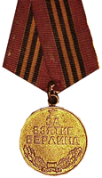 | Capture of Berlin Citation  Awarded for reaching a total games played of 50+  Russian Decoration
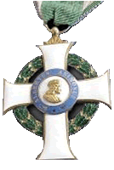 | Order of Albert  Awarded for reaching a total games played of 25+  German Decoration
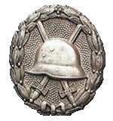 | Soldier Wounded in Battle  Awarded to those members who unfortunately find themselves at a rate of under 1600 after 6 months or more of membership and have played at least 30 games.  German Decoration

The Cross of the Combatant Volunteer of the Resistance  This bronze gilt cross was instituted on 15th April 1954 and shows the cross of Lorraine on the obverse and "COMBATTANT VOLONTAIRE RESISTANCE" in the reverse medallion.  As its title indicates, it was awarded to those Resistance members who voluntarily took up arms against the occupying German forces. | 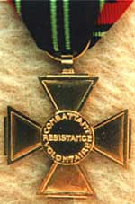
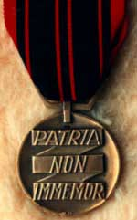 | The French Resistance Medal  General de Gaulle, as head of the Free French Forces, authorised this bronze medal on 9th February 1943 to acknowledge the courage of the members of the French Resistance.  Under the Lorraine cross on the obverse, the starting date of the German occupation of France , 17th June 1940, can be observed in Roman figures. The reverse inscription reads "PATRIA / NON / IMMEMOR" (The fatherland is not forgetting). In special cases a rosette on the ribbon was authorised.
The Medal for Voluntary Service in the Free French Forces (FFF)  Those who had volunteered for service in the FFF before 1st August 1943 were eligible for award of this silvered Lorraine Cross. It was instituted on 4th April 1946. | 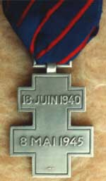
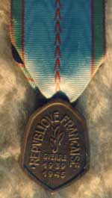 | The War Commemorative Medal 1939-1945  Adopted on 21st May 1946, this somewhat pear-shaped medal was awarded to all military personnel for service in a recognized unit.  The pale blue ribbon with red and green side stripes has a row of red Vs (Victoire, Victory) running down the centre. A number of bars were created for this medal:  "FRANCE", "NORVEGE", "ITALIE" "LIBERATION", "ALLEMAGNE", "GRANDE BRETAGNE", "U.R.S.S." for European land or air campaigns, "AFRIQUE" and "EXTREME ORIENT" for non-European theatres of war, "ATLANTIQUE", "MEDITERANNEE", "MANCHE" and "MER DU NORD" to commemorate maritime operations and also "DEFENSE PASSIVE" and "ENGAGE VOLONTAIRE".  From 8th November 1952 on, a bar with a red enamelled star could be worn if the recipient had received a war wound.
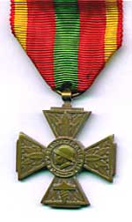 | 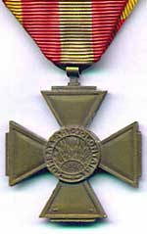
Obverse View | Reverse View
The Cross of the Combatant Volunteer of the War 1939-1945
This cross with the self-explanatory title is identical to the one awarded for WWI but for the dates "1939-1945" in the reverse medallion. The ribbon is an inverted pattern of the WWI version. It was authorised on 4th February 1953.
Copyright © 1995-2002 Andy Forbes [except where stated] All rights reserved www.64-baker-street.org

Honours and Medals — The Croix de Guerre — France

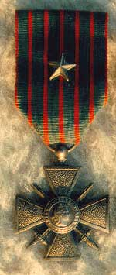 | 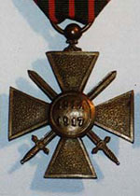
Obverse View | Reverse View
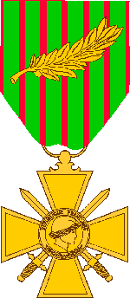 | 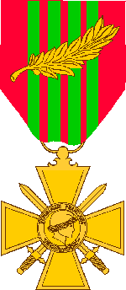
World War I | World War II
Background
The French Croix de Guerre was established on 8th April 1915 to commemorate individual mentions in dispatches during WWI. The medal was again authorised, with changes indicated above, in 1939 for WWII.
During WWI and WWII, the French Croix de Guerre was awarded to both U.S. Army units and to individuals. The Croix de Guerre may be awarded at different levels of command. The level of the awarding command determines the appurtenance worn on the ribbon. The bronze palm indicates awarded by the Army; a silver gilt star by a corps; a silver star by a division; and bronze star by a regiment or brigade.
The French Fourragére is authorised for both permanent and temporary wear. Personnel assigned to a unit which was awarded the fourragére may wear the fourragére while assigned to the unit.

Design
A bronze cross, 1 9/16 inches wide, surmounted by crossed swords hilt down saltirewise, overall a disk bearing the Head of the Republic. The medals are the same for World War I and World War II, except the WWI has 1914-1918 on the reverse and WWII medal has 1939 on the reverse.

Ribbon:
WWI
The ribbon is 1 3/8 inches wide and consists of the following stripes: 1/16 inch old glory red; 5/32 inch Irish green; 1/16 inch old glory red; 5/32 inch Irish green; 1/16 inch old glory red; 5/32 inch Irish green; 1/16 inch old glory red; 5/32 inch Irish green; 1/16 inch old glory red; 5/32 inch Irish green; 1/16 inch old glory red; 5/32 inch Irish green; 1/16 inch old glory red.
WWII
The ribbon is 1 3/8 inches wide and consists of the following stripes: 9/32 inch Old Glory Red; 5/32 inch Irish Green; 1/16 inch Old Glory Red; 5/32 inch Irish Green; 1/16 inch Old Glory Red; 5/32 inch Irish Green; 1/16 inch Old Glory Red; 5/32 inch Irish Green; 9/32 inch Old Glory Red.

Streamers
A streamer is displayed on the organisational flag/guidon to indicate award of the Croix de Guerre. The streamers are the same colour and pattern as the ribbon for the medal. Army units may display the Croix de Guerre on ceremonial occasions by pinning it on the streamer. The inscription and device will be as indicated in the unit's lineage and honours.
World War I Streamer
World War II Streamer
Fourragére:
The French fourragére may be awarded by the French government if a unit was cited twice in the dispatches. Award of the fourragére is not automatic and requires a specific decree of the French government. The fourragére is the same colours as the ribbon for the Croix de Guerre. If a unit is cited four times, the fourragére colours are changed to that of the French Medaille Militaire instead of the Croix de Guerre.
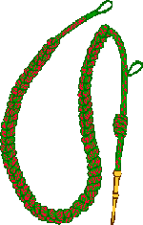 | 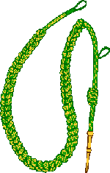
WWI (Two Citations) | WWI (Four Citations)
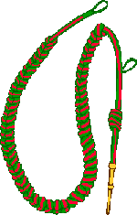 | 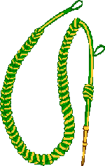
WW2 (Two Citations) | WW2 (Four Citations)
Copyright © 1995-2002 Andy Forbes [except where stated] All rights reserved www.64-baker-street.org

Honours and Medals — The Croix de Guerre — France

Obverse View | Reverse View
World War I | World War II
Background
The French Croix de Guerre was established on 8th April 1915 to commemorate individual mentions in dispatches during WWI. The medal was again authorised, with changes indicated above, in 1939 for WWII.
During WWI and WWII, the French Croix de Guerre was awarded to both U.S. Army units and to individuals. The Croix de Guerre may be awarded at different levels of command. The level of the awarding command determines the appurtenance worn on the ribbon. The bronze palm indicates awarded by the Army; a silver gilt star by a corps; a silver star by a division; and bronze star by a regiment or brigade.
The French Fourragére is authorised for both permanent and temporary wear. Personnel assigned to a unit which was awarded the fourragére may wear the fourragére while assigned to the unit.

Design
A bronze cross, 1 9/16 inches wide, surmounted by crossed swords hilt down saltirewise, overall a disk bearing the Head of the Republic. The medals are the same for World War I and World War II, except the WWI has 1914-1918 on the reverse and WWII medal has 1939 on the reverse.

Ribbon:
WWI
The ribbon is 1 3/8 inches wide and consists of the following stripes: 1/16 inch old glory red; 5/32 inch Irish green; 1/16 inch old glory red; 5/32 inch Irish green; 1/16 inch old glory red; 5/32 inch Irish green; 1/16 inch old glory red; 5/32 inch Irish green; 1/16 inch old glory red; 5/32 inch Irish green; 1/16 inch old glory red; 5/32 inch Irish green; 1/16 inch old glory red.
WWII
The ribbon is 1 3/8 inches wide and consists of the following stripes: 9/32 inch Old Glory Red; 5/32 inch Irish Green; 1/16 inch Old Glory Red; 5/32 inch Irish Green; 1/16 inch Old Glory Red; 5/32 inch Irish Green; 1/16 inch Old Glory Red; 5/32 inch Irish Green; 9/32 inch Old Glory Red.

Streamers
A streamer is displayed on the organisational flag/guidon to indicate award of the Croix de Guerre. The streamers are the same colour and pattern as the ribbon for the medal. Army units may display the Croix de Guerre on ceremonial occasions by pinning it on the streamer. The inscription and device will be as indicated in the unit's lineage and honours.
World War I Streamer
World War II Streamer
Fourragére:
The French fourragére may be awarded by the French government if a unit was cited twice in the dispatches. Award of the fourragére is not automatic and requires a specific decree of the French government. The fourragére is the same colours as the ribbon for the Croix de Guerre. If a unit is cited four times, the fourragére colours are changed to that of the French Medaille Militaire instead of the Croix de Guerre.
WWI (Two Citations) | WWI (Four Citations)
WW2 (Two Citations) | WW2 (Four Citations)
Copyright © 1995-2002 Andy Forbes [except where stated] All rights reserved www.64-baker-street.org

Honours and Medals — The George Cross (G.C.) — Great Britain

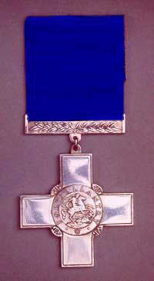
The George Cross
The George Cross was instituted by Royal Warrant on the 24th September 1940.
King George VI had been greatly moved by the fortitude and courage displayed by many civilians and by those engaged in bomb and mine disposal duties during the Blitz, and wanted these outstanding acts of bravery to be suitably recognised. Several awards already existed for which civilians were eligible and which could also be given to servicemen and women for acts of great heroism performed in circumstances other than battle. These awards included the Empire Gallantry Medal, the Albert Medals for Saving Life on Land and at Sea and the Edward Medals for Mines and Industry, but none matched the distinction of the Victoria Cross. The King, with his advisors, decided to create a new decoration which would be equivalent in status with the VC.
The Empire Gallantry Medal was abolished and surviving holders, together with those who had won it posthumously since the outbreak of war, had their medals exchanged for the George Cross. Awards of the Albert and Edwards Medals continued, but by the early 1970's it was acknowledged that there was little public appreciation of their importance. No further awards were made, and in 1971 it was announced that surviving holders of these medals would have their awards translated to the George Cross.
The George Cross was designed by Percy Metcalfe, CVO, RDI. and is made of silver by the Royal Mint. The colour of the ribbon is officially described as 'Garter' blue. The inscription on the obverse is: "For Gallantry".
The recipient's title, full name, rank and, where appropriate, unit, are inscribed on the reverse of the cross together with the date. The date inscribed on the GC is the date of the award and not the date, or dates, of the deed.
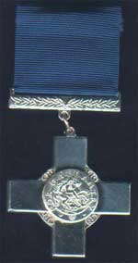 | 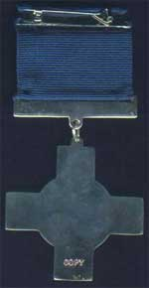
Obverse View | Reverse View
The most recent GC recipient was Sergeant S G Guthrie, New Zealand Police, Dunedin, 13th November 1990 (London Gazette 18th February 1992).
The youngest GC by direct award was to Mr John Bamford, 15 years and 7 months, Nottingham, 19th October 1952.
Women have always been eligible for the George Cross, and the following have received the award:

- Lieutenant O M C Sansom (later Mrs Hallowes), MBE, WTS (FANY) Special Operations Executive, October 1942 - May 1945
- Ensign V R E Szabo, WTS (FANY) SOE, April 1944 -February 1945
- Assistant Section Officer N Inayat-Khan, Women's Auxiliary Air Force/SOE, 16 June 1943 - 12 September 1944
- Miss B J Harrison, Air Stewardess, British Overseas Airway Corporation, Heathrow Airport, 8th April 1968

The total number of awards to date is 398 (JUly 2001).
There was no provision for the payment of any annuity contained in the original Warrant. However, from 4th February 1965 living holders of the GC were granted a tax-free annuity of £100. The figure remained at £100 until 15th August 1995 when it was raised to £1300.
The Imperial War Museum has a very fine collection of Victoria Crosses and George Crosses. The new permanent gallery devoted to displaying these medals was opened in May 1997. In addition to all the VCs and GCs in the Museum's collections, the display includes much interesting personal material belonging to the Museum relating to several recipients of these two awards whose medals are held in other collections.
See Related Resources on the World Wide Web section for a link to the Imperial War Museum.

Copyright © 1995-2002 Andy Forbes [except where stated] All rights reserved www.64-baker-street.org

Honours and Medals — The George Medal (G.M.) — Great Britain

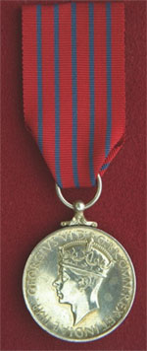
Background
The George Medal was instituted, together with the George Cross, by Royal Warrant on 24th September 1940. At the time there was a need to reward people from all walks of life. However, it was the intention of the authorities that the George Cross should stand supreme and that its position as the 'civilian Victoria Cross' should not be undermined by the award of larger numbers. The result was that the George Medal was introduced as a 'junior' to the George Cross.
Honorary George Medals can be and have been awarded to citizens of countries that are not members of the Commonwealth.
The George Medal is the 2nd highest, to the George Cross, gallantry medal that a civilian can win.

Criteria
The medal was awarded only for acts of great bravery and was intended primarily for civilians. Awards to the military were confined to actions for which purely military honours were not normally granted.

Description
A circular silver medal 1.42 inches in diameter.

Obverse
The obverse shows a crowned effigy of the reigning monarch and a legend.

Reverse
The reverse shows St. George on horseback slaying the Dragon with the legend THE GEORGE MEDAL around the top edge of the medal.

Mounting
A single-toe scroll claw at the top of the medal has a hollow ball through which a larger silver ring passes.

Ribbon
The red ribbon is 1.25 inches wide, with five equally spaced thin blue stripes.

Bar
The silver, slip-on bar is laurelled and is awarded for a further act of bravery.

Copyright © 1995-2002 Andy Forbes [except where stated] All rights reserved www.64-baker-street.org

Honours and Medals — The Légion d'Honneur (The Legion of Honour) — France

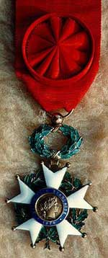 | 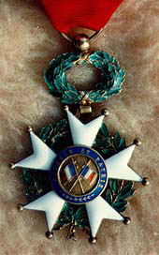
Obverse View | Reverse View
Created in l802 by Napoleon Bonaparte, the Légion d'Honneur is the highest award given by the French Republic for outstanding service to France, regardless of the social status or the nationality of the recipients. The President of the Republic is the Grand Master of the Order of the Légion d'Honneur. A Grand Chancellor, who is chairman of the Council of the Order, supervises its administrative services.

History
Napoleonic Period
The Legion of Honour was founded by Napoleon Bonaparte. Following a dinner in his home at Malmaison in February l802 to which he had invited several friends, including a general and a celebrated mathematician. Napoleon expressed his desire to reward men both for outstanding military accomplishments as well as for other distinguished service to the State. He rejected the suggestion to restore the Cross of Saint Louis, a military award created in 1693, and abolished in 1792 during the French Revolution.
Although this proposal was greeted coolly, since many hoped to re-establish the class distinctions eliminated by the revolutionaries of 1789, Napoleon proceeded to set down his ideas and submitted his plan to the Council of State early in May 1802. In spite of considerable opposition, Napoleon remained adamant and refused to accept the recommendation that the award be restricted to military men. After heated debate, the Council finally adopted the plan, 14 to 10, and it was subsequently passed in the Legislative Assembly.
The Légion d'Honneur was established by law on 19th May, 1802. In expressing his reasons for creating the Order, Napoleon said: "It will be an institution which will further all our republican laws and strengthen the Revolution. It will remove all distinctions of nobility, which placed inherited glory above acquired glory and descendants of great men above great men." One of the original supporters of Napoleon's plan had said that the would reward "actions considered beyond all recompense."
At first the Legion of Honour was made up of cohorts, corresponding to territorial divisions, with headquarters throughout France in the chateaux and ecclesiastical palaces that had been confiscated during the Revolution. Each Legionnaire received an annual honorarium according to his rank and his name was inscribed on a marble tablet in the headquarters of his cohort, as well as on similar tablets in the Invalides in Paris.
Until 1809 each cohort had its own local organisation, headed by a Grand Officer, a Treasurer and a Council of Administration. The central administrative body was a Grand Council, presided over by the Grand Chancellor, who was assisted by a Treasurer General. In the beginning each person admitted to the Legion of Honour had to swear "on his honour, to devote himself to serving the Republic." In 1804, after Napoleon had become Emperor, the last word was replaced by "welfare of the Empire."
Napoleon bestowed the Légion d'Honneur for the first time on 15th July, 1804 in a magnificent military and religious ceremony. Along the first to be honoured were eighteen marshals, five cardinals and a number of scholars, scientists, writers and composers. By 1812, 1,400 civilians had been decorated.

From the Restoration to the Present Day
Louis XVIII confirmed the titles that had been granted under the Empire but the Government was often accused of being too generous in awarding the Legion of Honour. Under the Restoration the prerogatives which accompanied the various ranks were abolished and later members no longer received an annual honorarium.
Although, during the Hundred Days, Napoleon had revoked the Legions of Honour bestowed by Louis XVIII, the Order itself was maintained; but there was an attempt to diminish its prestige by giving it second place after the Order of Saint Michael and the Holy Ghost or the Royal and Military Order of Saint Louis.
Louis-Philippe abolished these decorations and restored to the Légion d'Honneur its value and importance. The creation of the Military Medal in 1852 did not detract from the significance of the Legion. The organic decree of 16th March, 1852 concerning the nobility acquired upon becoming a member of he Legion of Honour is still in force, even if today certain provisions are less strictly observed.

Organisation

Administration
The organisation of the Legion of Honour has remained the same since 1852. The Chief of State, the President of the Republic, is accorded the rank of Grand Cross upon taking office and automatically becomes the Grand Master of the Order. After his term expires, he remains a Grand Cross.
The Grand Master chooses and appoints the Grand Chancellor from among the Grand Crosses or the Grand officers. This is one of the highest positions in the French Republic and the appointment is for a six-year renewable term. The Grand Chancellor is chairman of the Council of the Order and directs the administrative services housed in the Palace of the Legion of Honour in Paris. He represents the Legion of Honour in litigation, is the keeper of the Seal of the Order and presents to the Chief of State all the reports, draft decrees, regulations and decisions concerning the Legion of Honour. Each new President of the Republic receives the Collar of the Grand Master of the Order from the Grand Chancellor.

Admission to the Order
Members of the Legion of Honour are appointed for life. In peacetime, twenty years of distinguished military or civilian service are required for admission to the Order. Candidates are nominated by the various Ministers, who submit their names to the Grand Chancellor. He in turn presents them to the President of the Republic.

The Légion d'Honneur has five ranks
- Knights ("Chevaliers")
- Officers
- Commanders
- Grand Officers
- Grand Crosses

The Grand Officers and the Grand Crosses are known as the Dignitaries of the Order. Members are eligible for promotion after a certain number of years at each rank, but these requirements, too, can be waived under extraordinary circumstances.
The Dignitaries generally receive their medals from the Chief of State himself but the ceremonial for the other ranks varies. A Legionnaire can be received into the Order only by another Legionnaire of at least equal rank. These requirements do not apply to foreigners receiving the award. The oath which the Legionnaires had sworn to the various regimes was abolished during the Third Republic.
Women as well as men are eligible for membership in the Legion of Honour. There is no authentic proof that Napoleon Bonaparte ever decorated a woman, but Napoleon III bestowed the Légion d'Honneur upon women in various walks of life. Under the Third Republic the heroines of the war of l870 were honoured as well as a famous woman archaeologist and other women who had devoted themselves to outstanding charitable projects.
One hundred and ten women held the Légion d'Honneur in 1914; by 1939, 3,000 had been decorated. The famous aviatrix, Maryse Bastié, was the first woman to be promoted to the rank of Commander, in recognition of her military exploits. The first women to become Grand Officers were Marshal Lyautey's widow, who was honoured shortly before her death in January 1953, and a few days later, Colette, the celebrated novelist.
Foreigners may be nominated for membership in the Legion of Honour by the Minister of Foreign Affairs. They can be admitted at any rank and promoted regardless of how long they have been members.
No emblem had ever received the Légion d'Honneur until Napoleon III bestowed it upon the flags of regiments that had distinguished themselves during the Italian campaigns. Only one flag was so honoured in 1870, the standard of the 57th Régiment de Ligne. From 1859 to 1947, fifty-seven flags were decorated, including those of the Paris and Reims fire brigades, the "Ecole Polytechnique", the "Ecole Navale" and the "Ecole de l'Air". In 1954, President René Coty awarded the Legion of Honour to the flags of the Le Havre and Rouen fire brigades.
The award was first given to French cities during the Hundred Days. After 1870 the Republic rewarded several cities, including Paris (1900). Thirty-one were decorated between 1914 and 1917, sixteen of them during World War I.

Insignia
The medal has changed very little since 1804. The profile of Napoleon on the front and the eagle on the back were replaced under the Restoration by Henry IV and three fleurs-de-lis, symbol of the Bourbon dynasty. Two tri-colour flags were subsequently substituted for the royal insignia. Since 1870 the head of "Marianne", symbolic figure of the Republic, has appeared on the front of the medal, the tri-colour flags on the back. The inscription on the front reads "République Française" (French Republic) and on the back "Honneur et Patrie" (Honour and Fatherland). The medal is shaped like a five-sided double-pointed star, and is made of white enamel. It is encircled by a green wreath of oak and laurel leaves and surmounted by a smaller, similar wreath. The star and the red moiré ribbon from which it is suspended have never varied.

The Palace of the Legion of Honour
The old de Salm mansion on the Quai d'Orsay in Paris has housed the central offices and the Museum of the Legion of Honour since 1804. Built shortly before the French Revolution, the building was burned by the Commune in 1871 and reconstructed from a fund raised among the Legionnaires. The mansion looks today much as it did in 1789, with the exception of the wings added in 1925 for the Museum established by General Dubail, Grand Chancellor from 1918 to 1934.
The Museum possesses a complete collection of the Orders of the former Regimes and their various insignia, along with paintings, engravings and important historical mementos.
Copyright © 1995-2002 Andy Forbes [except where stated] All rights reserved www.64-baker-street.org

Honours and Medals — The Most Excellent Order of the British Empire

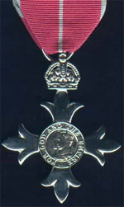 | 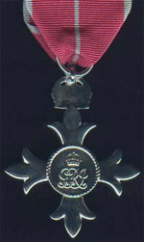
Obverse View | Reverse View

The five classes of this Order are as follows:

- Knights or Dames Grand Cross, (GBE)
- Knights or Dames Commanders, (KBE or DBE)
- Commanders, (CBE)
- Officers, (OBE)
- Members, (MBE)

With WWI lasting longer than expected and no suitable way to reward services to the war effort by civilians at home and servicemen in support positions, King George V created another order with five levels.
The first two levels confer knighthood. The three levels - Commander, Officer and Member.
The order could be given generously for services to the Empire at home, in India and in the Dominions and colonies. The order was created mainly to award non-combatant services to the war and was to include women, whom most existing orders excluded.
When the order was created in 1917 it had only one division, but was divided into Civil and Military divisions in 1918. The order at any level can be awarded for gallantry as well as for service.
The order took an abrupt change in 1937 when the insignia and the colour of the ribbon were changed.

Description
For the CBE there is no star and the neck badge (2.5 inches wide), is smaller than that of the KBE.
Medal
Obverse
Original Badge
A cross patonce (four arms with three points on each arm) of silver-gilt with the arms enamelled pearl-grey, surmounted by an Imperial Crown. The circular centre, in gold, shows the figure of Britannia, holding a trident and seated beside a shield bearing the national flag. The centre is surrounded by a circular band, enamelled crimson and bearing the motto FOR GOD AND THE EMPIRE in gold.

Current Badge (after 1937)
As above except that in the centre, in gold, are the crowned effigies of King George V and his consort Queen Mary. Neither the original nor the current OBE and MBE badges are enamelled.

Reverse
A rope circle with the current Royal Cypher, surmounted by an Imperial Crown and with a hallmark on the lower limb.

Bar
A silver emblem of two oak leaves is worn on the riband when the appointment to the order is for gallantry.

Mounting
A ring is attached to the top of the crown through which a larger ring passes.

Ribbon
Original
The civil ribbon was purple (1.5 inches wide). The military ribbon had a narrow central stripe of scarlet added.

Current (after 1937)
The civil ribbon is rose-pink with pearl grey edges. The military ribbon has a narrow central stripe of pearl grey added.

Dates
The order was established in June 1917. In December 1918, military and civil divisions were established. On 9th March 1937, the insignia and ribbon were changed. After 1st January 1958, gallantry awards were recognized with silver oak leaves.

Copyright © 1995-2002 Andy Forbes [except where stated] All rights reserved www.64-baker-street.org

Honours and Medals — The US Distinguished Service Cross — United States

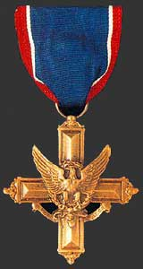
Background
The Distinguished Service Cross was established by President Woodrow Wilson on 2nd January, 1918. General Pershing, Commander-in-Chief of the Expeditionary Forces in France, had recommended that recognition other than the Medal of Honor, be authorized for the Armed Forces of the United States for service rendered, in like manner, to that awarded by the European Armies. The request for establishment of the medal was forwarded from the Secretary of War to the President in a letter dated 28th December, 1917. The Act of Congress establishing this award (193-65th Congress) dated 9th July, 1918 is contained in Title 10 United States Code (USC) 3742. The establishment of the Distinguished Service Cross was promulgated in War Department General Order No. 6, dated 12th January, 1918.
The first design of the Distinguished Service Cross was cast and manufactured by the United States Mint at Philadelphia. The die was cast from the approved design prepared by Lieutenant Aymar E. Embry, Engineers Officer Reserve Corps. Upon examination of the first medals struck at the Mint, it was considered advisable to make certain minor changes to add to the beauty and the attractiveness of the medal. Due to the importance of the time element involved in furnishing the decorations to General Pershing, one hundred of the medals were struck from the original design and numbered 1 to 100. These medals were furnished with the provision that these crosses be replaced when the supply of the second design was accomplished which would also be numbered 1 to 100.

Criteria
The Distinguished Service Cross is awarded to a person who, while serving in any capacity with the Army, distinguishes himself or herself by extraordinary heroism not justifying the award of a Medal of Honor; while engaged in an action against an enemy of the Unites States; while engaged in military operations involving conflict with an opposing/foreign force; or while serving with friendly foreign forces engaged in an armed conflict against an opposing Armed Force in which the United States is not a belligerent party. The act or acts of heroism must have been so notable and have involved risk of life so extraordinary as to set the individual apart from his or her comrades.
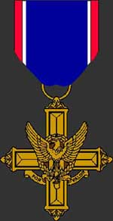 | 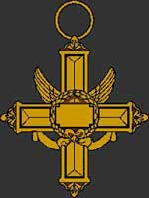
Obverse view | Reverse view
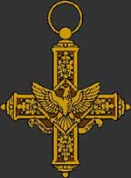
The original design
Description
A cross of bronze, 2 inches in height and 1 13/16 inches in width with an eagle on the center and a scroll below the eagle bearing the inscription "FOR VALOR". On the reverse side, the center of the cross is circled by a wreath with a space for engraving the name of the recipient.

Ribbon
The ribbon is 1 3/8 inches wide and consists of the following stripes: 1/8 inch Old Glory Red; 1/16 inch White; 1 inch Imperial Blue; 1 1/16 inch White; and 1/8 inch Old Glory Red.

Copyright © 1995-2002 Andy Forbes [except where stated] All rights reserved www.64-baker-street.org

Honours and Medals — The US Medal of Freedom — United States

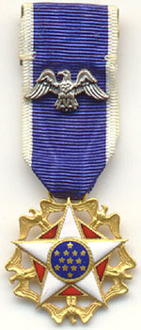
The highest civilian decoration of the United States is the Presidential Medal of Freedom. This award was established as the Medal of Freedom by President Harry S. Truman on 6th July 1945. It was originally an award for meritorious service on behalf of the United States, especially in wartime.
The medal was re-established by President John F. Kennedy on 22nd February 1963, with its current name. The scope of the award was also broadened.
The Presidential Medal of Freedom is awarded to individuals who have made especially meritorious contributions to the security or national interests of the United States, to world peace, or to cultural or other significant public or private endeavors.
The following documentation is from the: US National Archives and Records Administration Federal Register

Chronological History of Executive Orders for the Medal
Executive Order 9586 - The Medal of Freedom
Source: The provisions of Executive Order 9586 of July 6, 1945, appear at 10 FR 8523, 3 CFR, 1943-1948 Comp., p. 410, unless otherwise noted. (see note 1)
By virtue of the authority vested in me as President of the United States and as Commander in Chief of the armed forces of the United States, it is ordered as follows:
[Introductory paragraph amended by Executive Order 10336 of Apr. 3, 1952, 17 FR 2957, 3 CFR, 1949-1953 Comp., p. 858] (See note 2)
Section 1. Medal established. The Medal of Freedom is hereby re-established as the Presidential Medal of Freedom, with accompanying ribbons and appurtenances. The Presidential Medal of Freedom, hereinafter referred to as the Medal, shall be in two degrees.
[Sec. 1 amended by Executive Order 11085 of Feb. 22, 1963, 28 FR 1759, 3 CFR, 1959-1963 Comp., p. 719] (See note 3)
Sec. 2. Award of the Medal. (a) The medal may be awarded by the President as provided in this order to any person who has made an especially meritorious contribution to (1) the security or national interests of the United States, or (2) world peace, or (3) cultural or other significant public or private endeavors.
(b) The President may select for the award of the Medal any person recommended to the President for award of the Medal or any person selected by the President upon his own initiative.
(c) The principal announcement of awards of the Medal shall normally be made annually, on or about 4th July of each year; but such awards may be made at other times, as the President may deem appropriate.
(d) Subject to the provisions of this Order, the Medal may be awarded posthumously.
[Sec. 2 amended by Executive Order 11085 of Feb. 22, 1963, 28 FR 1759, 3 CFR, 1959-1963 Comp., p. 719; Executive Order 11515 of Mar. 13, 1970, 35 FR 4543, 3 CFR, 1966-1970 Comp., p. 905. Secs. 3-6 removed by Executive Order 11515 of Mar. 13, 1970, 35 FR 4543, 3 CFR, 1966-1970 Comp., p. 905]

Notes
(1) President Harry S. Truman
(2) President Harry S. Truman
(3) President John Fitzgerald Kennedy

Copyright © 1995-2002 Andy Forbes [except where stated] All rights reserved www.64-baker-street.org

